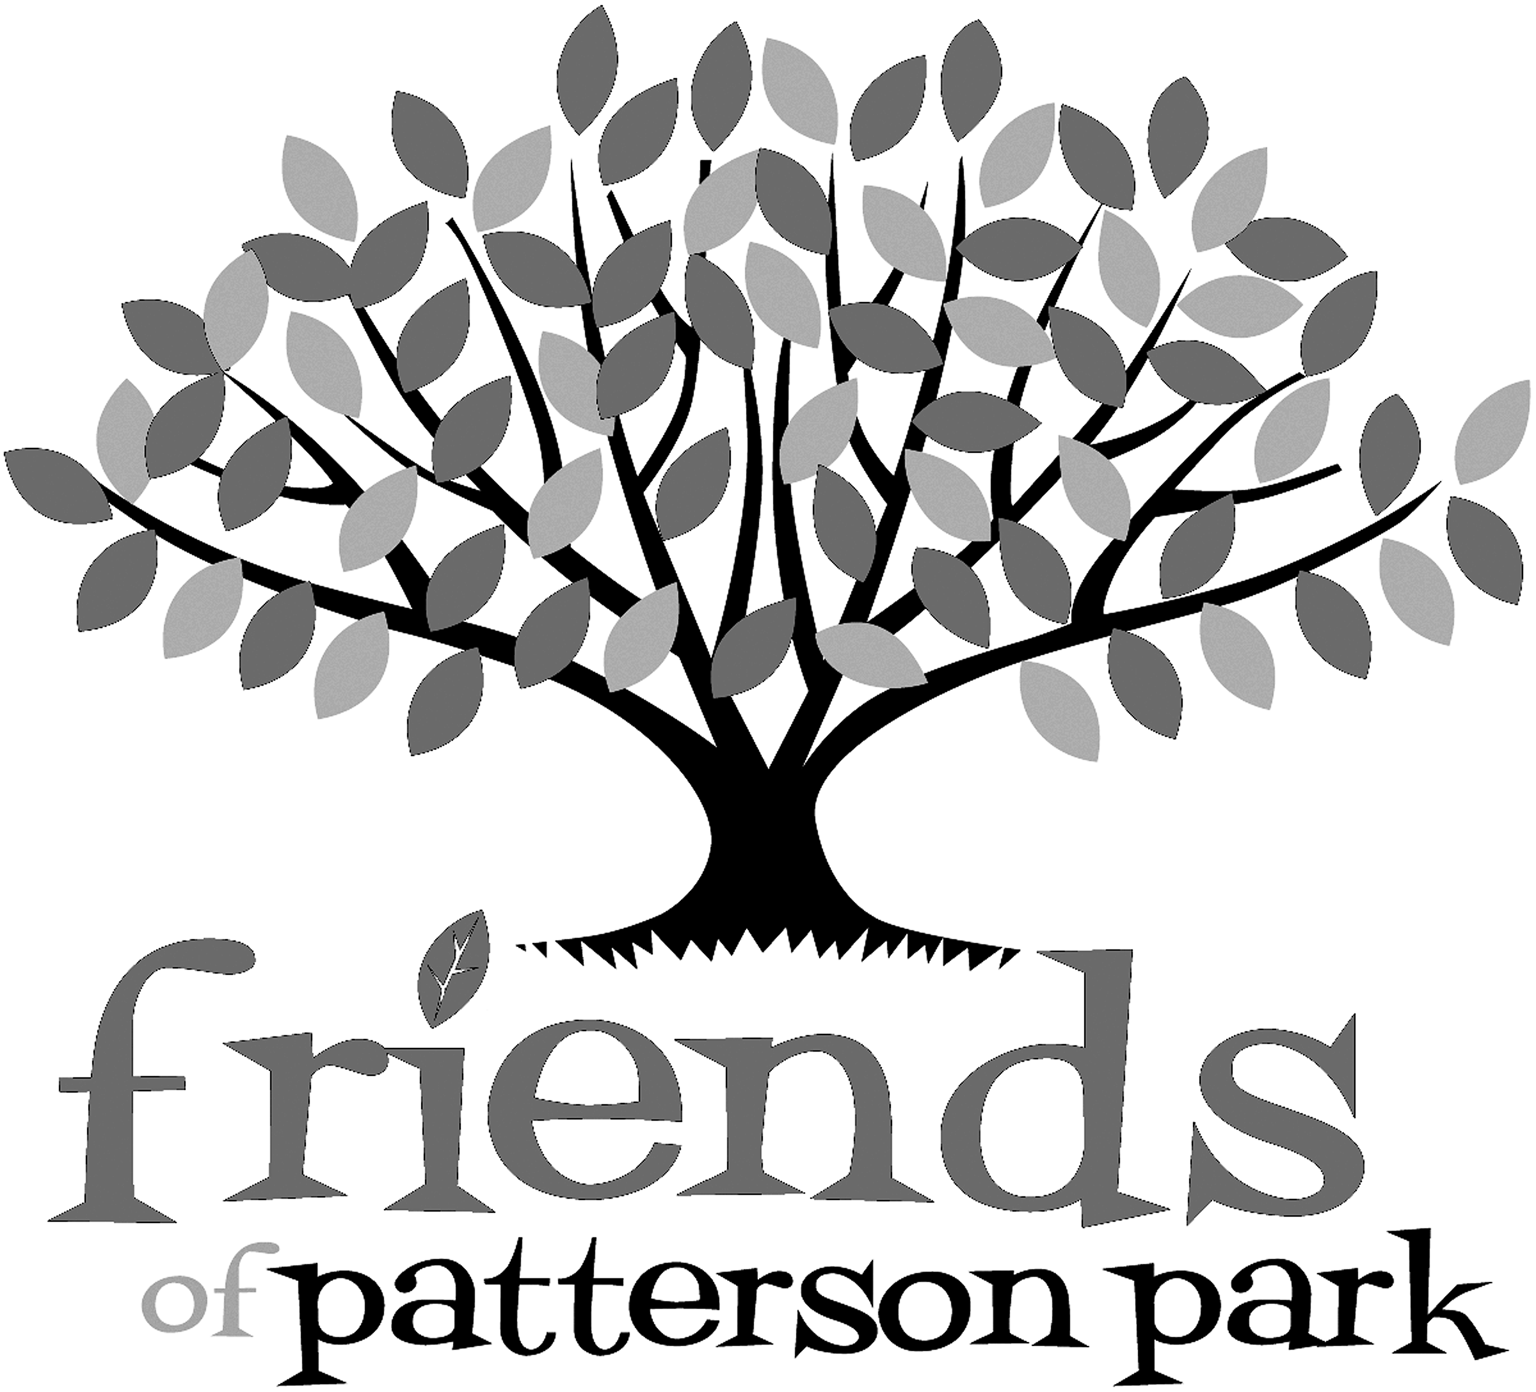
Friends of Patterson Park
Ambassador Program

Are you a people-person who enjoys interacting with various audiences and constituencies? Do you have experience advocating for and representing organizations, such as non-profits, your alma mater, or your employer? Have you thought about getting more involved with a non-profit but are not sure where to start? The Friends of Patterson Park ‘the Friends’ Ambassador Program seeks volunteers to participate in events throughout the year, during which you have the opportunity to meet new people and promote the important work done by the Friends.

What is a Friends of Patterson Park Ambassador?
An Ambassador is a volunteer who promotes Patterson Park and the Friends to the community. They are park lovers and supporters who understand the importance of our public green space as a vital asset to our community. Ambassadors help to highlight the important role the Friends plays in maintaining the parks vibrancy and expansive offerings, and support the promotion of the Friends throughout the area and city.

What is expected of an Ambassador?
We ask that Ambassadors commit to volunteering at least two events annually, which includes:
- Familiarizing yourself with general park information and upcoming events so you can best represent the Friends during events (training video provided)
- Set-up and breakdown of membership table at event
- Referring appropriate questions to key resource people within the Friends at the conclusion of events
- Providing overall feedback regarding event participation so the Friends may continue to evolve and improve its tabling efforts

What is expected of the Friends?
- Provide training video to volunteers that shares relevant information needed to successfully serve as an ambassador at any given event
- Share ambassador opportunities in a timely matter and appropriately staff each event, including pairing ambassadors with current volunteers for their first event
- T-shirt for all active Ambassadors so they may wear it when volunteering

